**Installing Arduino IDE with Adafruit Boards**

Arduino IDE + NeoPixels Library Installation:

<https://learn.adafruit.com/adafruit-neopixel-uberguide/arduino-library-installation>

Drivers for Gemma for Windows:

<https://learn.adafruit.com/adafruit-arduino-ide-setup/windows-setup>

Adding the Gemma board to Arduino IDE:

<https://learn.adafruit.com/add-boards-arduino-v164/setup>

**NeoPixels:**

[**https://learn.adafruit.com/adafruit-neopixel-uberguide/overview**](https://learn.adafruit.com/adafruit-neopixel-uberguide/overview)

* Not your average LED ☺ Requires programming
* Ready-to-load code available as part of Adafruit NeoPixel library

**Getting started with Gemma**

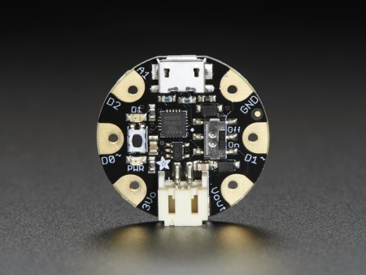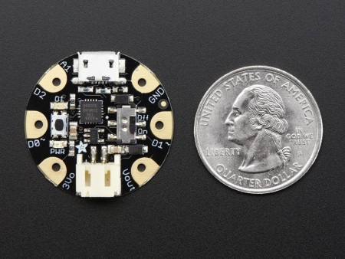

[**https://learn.adafruit.com/introducing-gemma**](https://learn.adafruit.com/introducing-gemma)

* Super small, **only 1.1" / 28mm diameter** and 0.28" / 7mm thick.
* Easy-to-sew or solder pads for embedding in your wearable project
* Low cost enough, you can use one for every weekend project
* ATtiny85 on-board, **8K of flash**, 512 byte of SRAM, 512 bytes of EEPROM

**Adafruit Color Sensor**

[**https://learn.adafruit.com/adafruit-color-sensors/overview**](https://learn.adafruit.com/adafruit-color-sensors/overview)

**Bluefruit LE**

[**https://learn.adafruit.com/adafruit-flora-bluefruit-le**](https://learn.adafruit.com/adafruit-flora-bluefruit-le)

* For use with Flora, but not Gemma due to memory constraints
* Adafruit app available for wireless control

**Getting started with Flora**

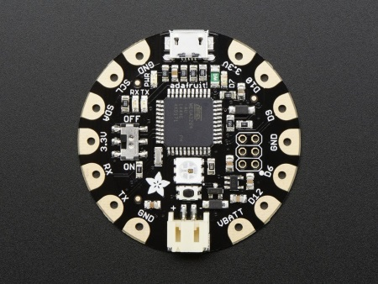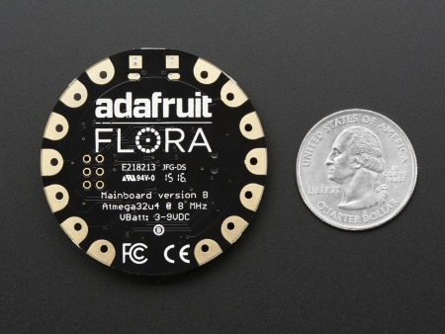

[**https://learn.adafruit.com/getting-started-with-flora**](https://learn.adafruit.com/getting-started-with-flora)

* 1.8" round x 0.3" thick
* Easy-to-sew or solder pads for embedding in your wearable project
* Based on the ATmega32u4 30K of usable flash memory